Warwick East State School
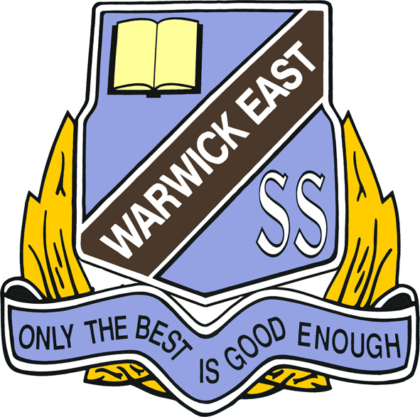

Prep Booklist 2025

1 pkt Coloured Pencils
10 Triangular lead pencils
10 Black Whiteboard Markers (2mm bullet tip)

8 Scrapbooks (72 pages)

8 Glue Sticks 35g-40g (Coloured is best to see where they have glued)
1 Pair 130mm Scissors (small children’s)

1 A3 Plastic Zip Wallet
1 Clear Plastic Simplex Wallet
1 Material Library Bag
1 Pencil Case - large size
1 Set of Headphones (not earbuds)

Optional Items
4 Reams (500sheet) Photocopy Paper
2 Boxes of Tissues

All items to be clearly named

