Warwick East State School
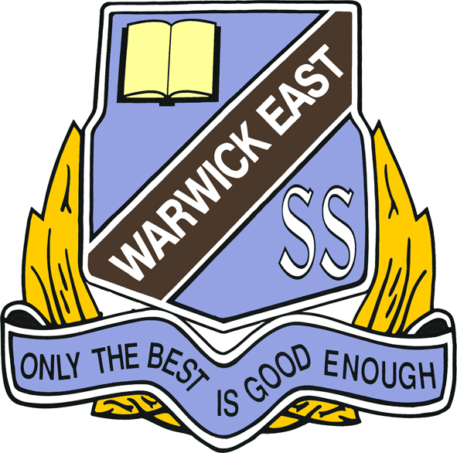

Year 1 Booklist 2025

20 HB Pencils (No novelty pencils please)
2 pkt Coloured Pencils
1 (12pk) Texta Pens
1 Pkt Twistable Crayons
10 Black Whiteboard Markers
1 Pair 130mm Scissors
10 Glue Sticks 35g-40g
2 Pencil Sharpeners with shaving catcher
4 Erasers - white (not novelty items)
1 x 2.5cm Wooden or plastic ruler
5 x A4 Year 1 Red & Blue Lined Exercise Books
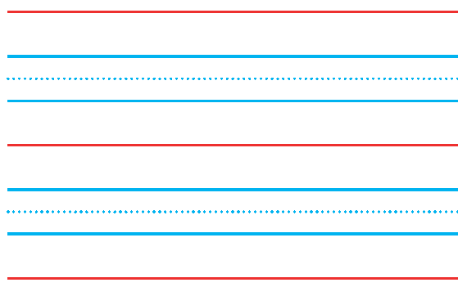
8 x Scrapbooks
2 x A4 Plastic Document Wallets with clip
1 Material Library Bag
1 Large Pencil Case
1 Set of Headphones (not earbuds)

Optional Items
4 Reams (500sheet) Photocopy Paper
2 Boxes of Tissues
All items to be clearly named

