Warwick East State School
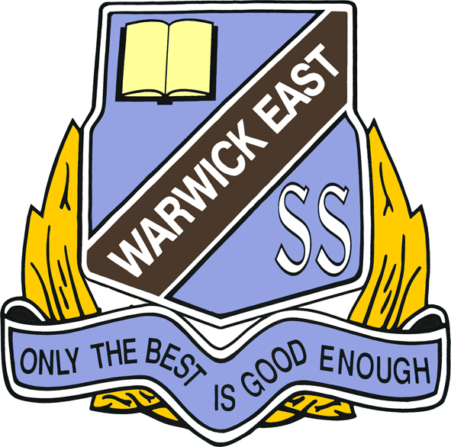

Year 3 Booklist 2025

1 (12pk) Twistable Crayons
2 pkts Coloured Pencils
20 HB Pencils (no novelty pencils please)
1 (12pk) Texta Pens
4 Highlighters - Different Colours
8 Whiteboard Markers
8 Glue Sticks 35g-40g
1 Pair 130mm Scissors
2 Metal Pencil Sharpeners - Dual Size (no novelty sharpeners)
4 Erasers - white (no novelty items)
1 Wooden Ruler (with centimetres and millimetres)

6 x A4 Year 3/4 Red & Blue Lined Exercise Books
2 x A4 10mm Quad Ruled Exercise Book
8 Scrapbooks

2 Plastic Simplex Wallets
2 Refillable Display Books (20 pockets) - NOT BLACK
1 Material Library Bag
1 Pencil Case
Australian Pocket Oxford Dictionary (Same dictionary used for Yr3 to Yr6)
1 Set of Headphones with microphone
1 Yamaha Plastic Recorder
Optional Items
4 Reams (500sheet) Photocopy Paper
2 Boxes of Tissues
All items to be clearly named

