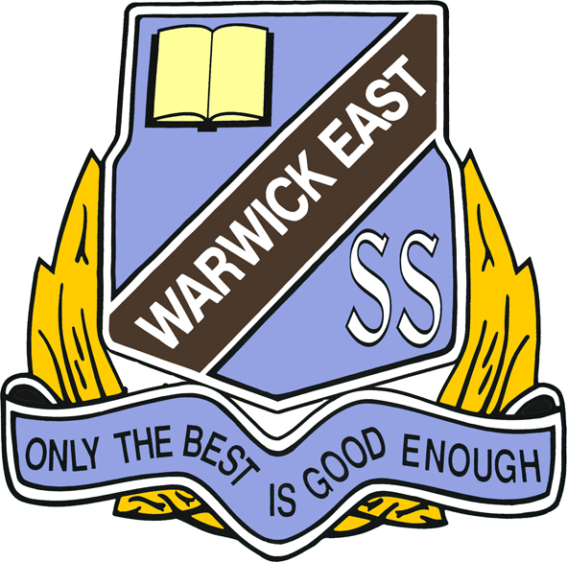

Warwick East State School

Year 6 Booklist 2025

Biros (2 Blue, 2 Black, 2 Red)
20 HB Pencils
1 pkt Coloured Pencils
1 pkt Texta Pens
2 Highlighter Pens - Different Colours
10 Whiteboard Markers (Blue or Black)
6 Erasers - (no novelty items)
4 Glue Sticks 35g-40g
2 Pencil Sharpeners
1 Ruler (Wooden or Plastic with mm/cm, not inches)
1 Pair 130mm Scissors
1 Art Block Sketchbook A3 - on spiral wire binding
11 A4 Blue Lined Exercise Books - 96 pages
4 A4 10mm Quad Books - 96 pages
2 Scrapbooks
1 Refillable Display Book - 20 pockets
2 Plastic Simplex Wallets - Different Colours
1 A4 Clip folder
Australian Pocket Oxford Dictionary (Same dictionary used for Yr3 to Yr6)
1 Pencil Case
1 Yamaha Plastic Recorder
1 Set of Earbud Headphones (AUX jack connector)
1 Basic non-scientific calculator
Optional Items
4 Reams (500sheet) Photocopy Paper 2 Boxes of Tissues
All items to be clearly named

